Acute Triangle
# Source: AI Source: Provided by: [Data Path: Persons Table -> ID Column: 1, Name_En Column: Motasem Essam] -> From: [ChatGPT] on [7/25/2026]
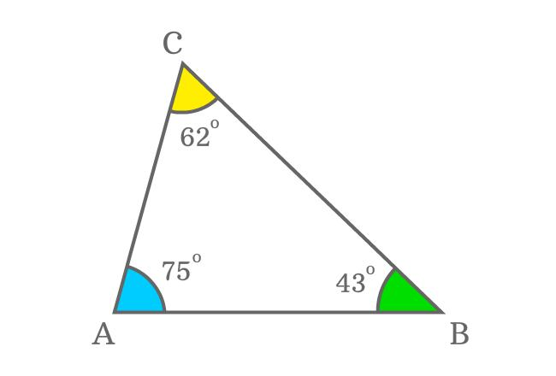
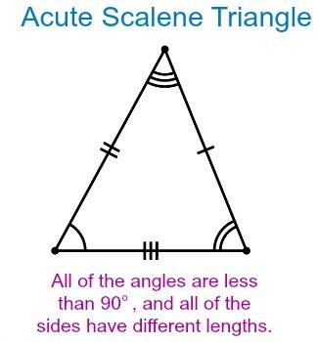
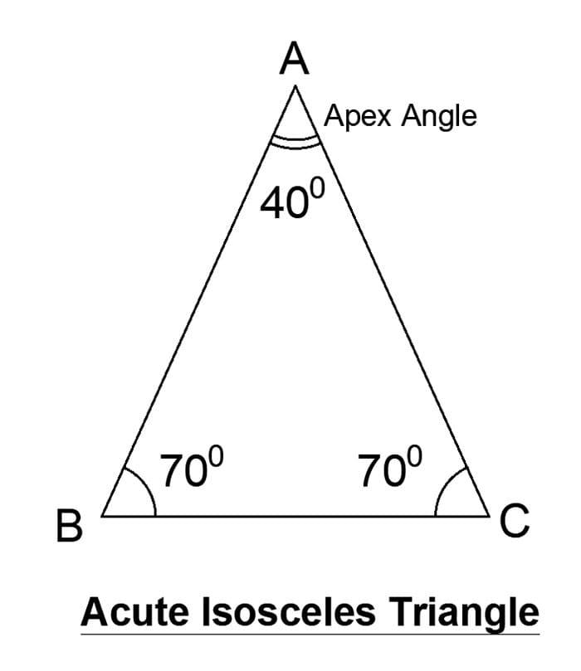
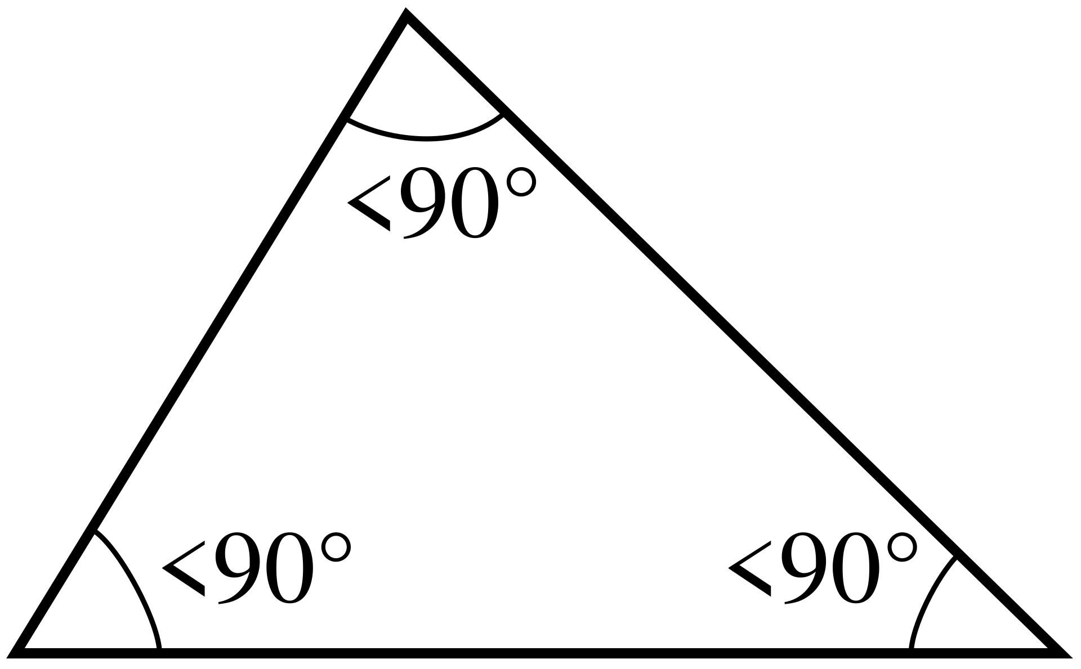
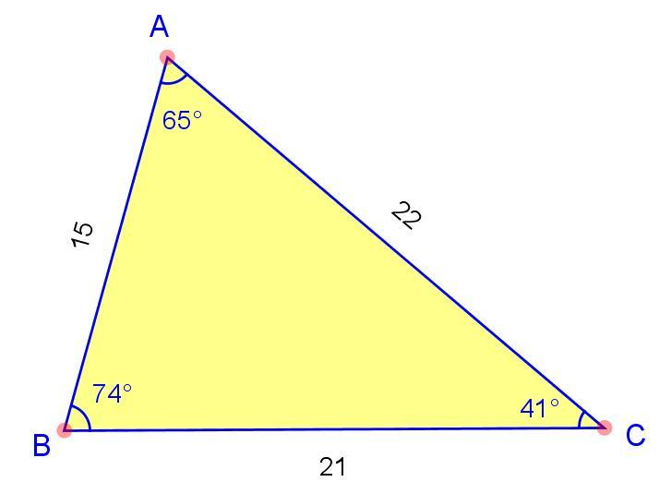
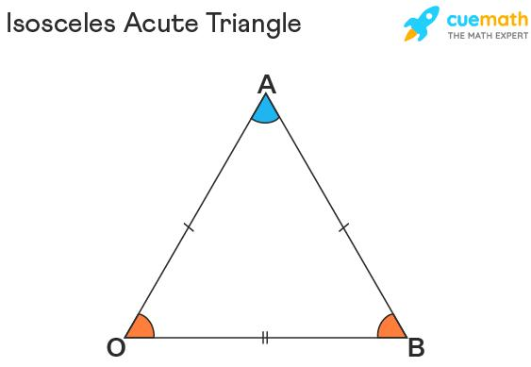

Definition
# Source: AI Source: Provided by: [Data Path: Persons Table -> ID Column: 1, Name_En Column: Motasem Essam] -> From: [ChatGPT] on [7/25/2026]
An Acute Triangle is a triangle in which all three interior angles are acute angles, meaning each angle is less than ${90}^{∘}$.
For triangle $ABC$:
$$\boxed{∠A<{90}^{∘}, ∠B<{90}^{∘}, ∠C<{90}^{∘}}$$
Because the three interior angles of every triangle sum to ${180}^{∘}$, an acute triangle satisfies:
$$\boxed{∠A+∠B+∠C={180}^{∘}}$$
with each angle between $0^{∘}$and ${90}^{∘}$.

Classification
# Source: AI Source: Provided by: [Data Path: Persons Table -> ID Column: 1, Name_En Column: Motasem Essam] -> From: [ChatGPT] on [7/25/2026]
Acute triangles are classified according to their sides as:
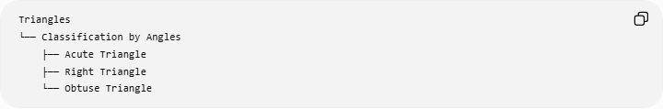
Triangles
└── Classification by Angles
├── Acute Triangle
├── Right Triangle
└── Obtuse Triangle
An acute triangle can also be classified by its sides:
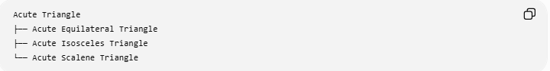
Acute Triangle
├── Acute Equilateral Triangle
├── Acute Isosceles Triangle
└── Acute Scalene Triangle

Important
# Source: AI Source: Provided by: [Data Path: Persons Table -> ID Column: 1, Name_En Column: Motasem Essam] -> From: [ChatGPT] on [7/25/2026]
An equilateral triangle is always acute, because all three angles are ${60}^{∘}$.
An isosceles or scalene triangle can be acute, right, or obtuse.

Fundamental Properties
# Source: AI Source: Provided by: [Data Path: Persons Table -> ID Column: 1, Name_En Column: Motasem Essam] -> From: [ChatGPT] on [7/25/2026]
1. All angles are less than ${90}^{∘}$
$$\boxed{0^{∘}<∠A,∠B,∠C<{90}^{∘}}$$
2. The angles sum to ${180}^{∘}$
$$\boxed{∠A+∠B+∠C={180}^{∘}}$$
3. There is no right angle
An acute triangle contains no ${90}^{∘}$angle.
4. There is no obtuse angle
An acute triangle contains no angle greater than ${90}^{∘}$.
5. The orthocenter lies inside
For an acute triangle, the three altitudes intersect at an orthocenter $H$located inside the triangle.
6. The circumcenter lies inside
The circumcenter $O$of an acute triangle also lies inside the triangle.
7. The incenter and centroid lie inside
The incenter $I$and centroid $G$are also inside every nondegenerate triangle, including acute triangles.

Side-Length Characterization
# Source: AI Source: Provided by: [Data Path: Persons Table -> ID Column: 1, Name_En Column: Motasem Essam] -> From: [ChatGPT] on [7/25/2026]
An acute triangle can be identified from its side lengths.
Let $c$be the longest side and $a,b$the other two sides.
The triangle is acute exactly when:
$$\boxed{c^{2}<a^{2}+b^{2}}$$
This follows from the Law of Cosines.
For comparison:
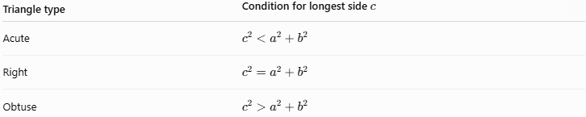
Triangle type | Condition for longest side $c$
Acute | $$c^{2}<a^{2}+b^{2}$$
Right | $$c^{2}=a^{2}+b^{2}$$
Obtuse | $$c^{2}>a^{2}+b^{2}$$

Examples

Example 1: Equilateral Acute Triangle
# Source: AI Source: Provided by: [Data Path: Persons Table -> ID Column: 1, Name_En Column: Motasem Essam] -> From: [ChatGPT] on [7/25/2026]
Consider:
$$∠A={60}^{∘}, ∠B={60}^{∘}, ∠C={60}^{∘}$$
Since:
$${60}^{∘}<{90}^{∘}$$
all three angles are acute.
Therefore, the triangle is an acute equilateral triangle.

Example 2: Acute Isosceles Triangle
# Source: AI Source: Provided by: [Data Path: Persons Table -> ID Column: 1, Name_En Column: Motasem Essam] -> From: [ChatGPT] on [7/25/2026]
Consider:
$$∠A={40}^{∘}, ∠B={70}^{∘}, ∠C={70}^{∘}$$
All three angles are less than ${90}^{∘}$, so the triangle is acute.
Because two angles are equal, it is also isosceles.

Example 3: Acute Scalene Triangle
# Source: AI Source: Provided by: [Data Path: Persons Table -> ID Column: 1, Name_En Column: Motasem Essam] -> From: [ChatGPT] on [7/25/2026]
Consider:
$$∠A={50}^{∘}, ∠B={60}^{∘}, ∠C={70}^{∘}$$
All three angles are different and all are less than ${90}^{∘}$.
Therefore, it is an acute scalene triangle.

Altitudes and Orthocenter
# Source: AI Source: Provided by: [Data Path: Persons Table -> ID Column: 1, Name_En Column: Motasem Essam] -> From: [ChatGPT] on [7/25/2026]
In an acute triangle, all three altitudes intersect inside the triangle.
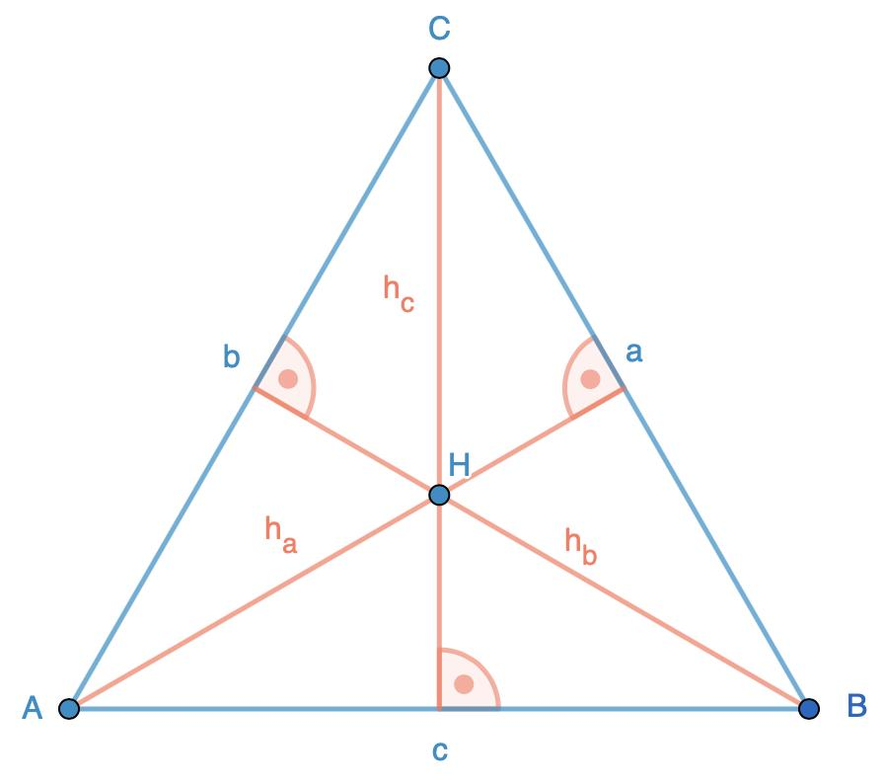
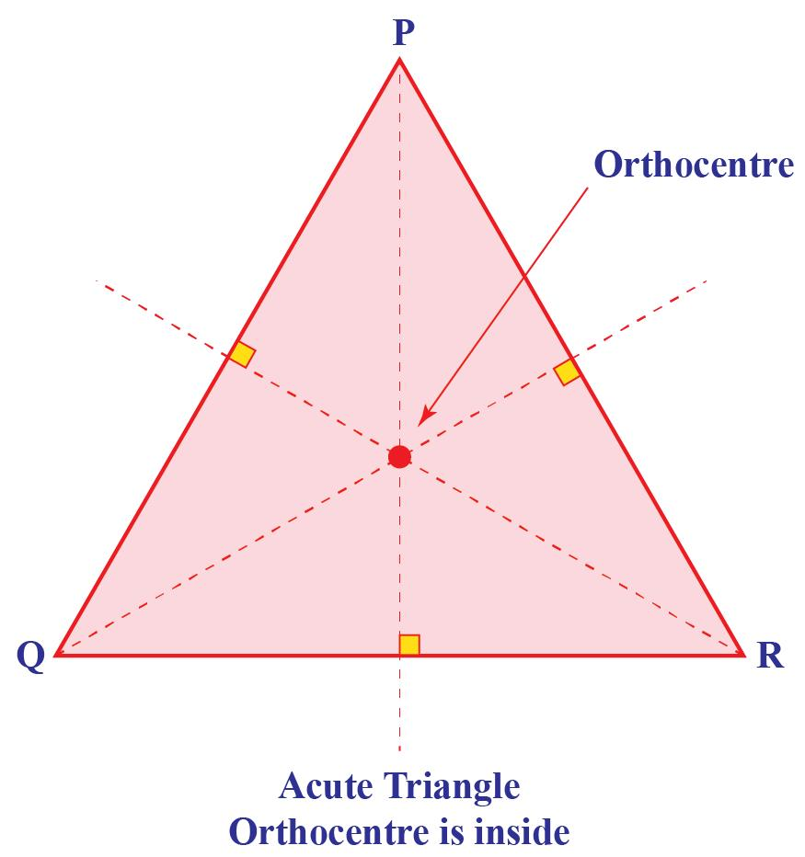
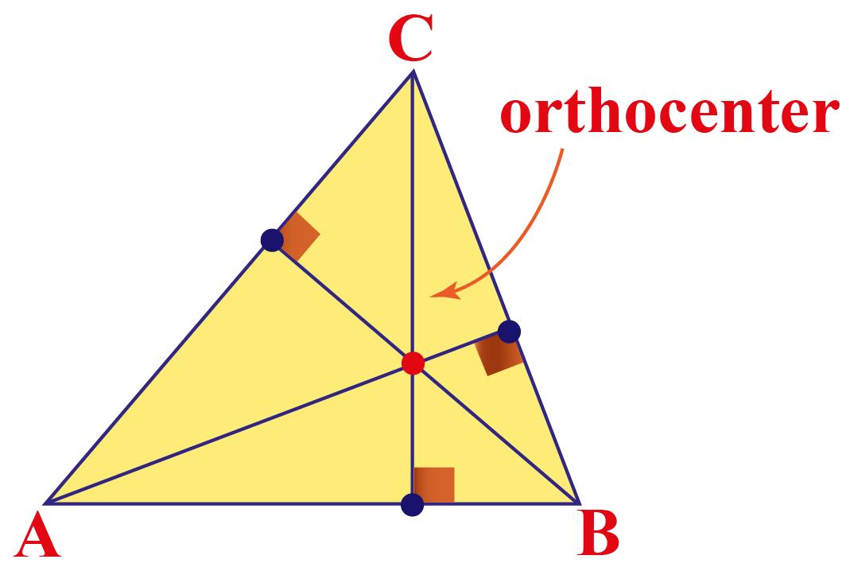
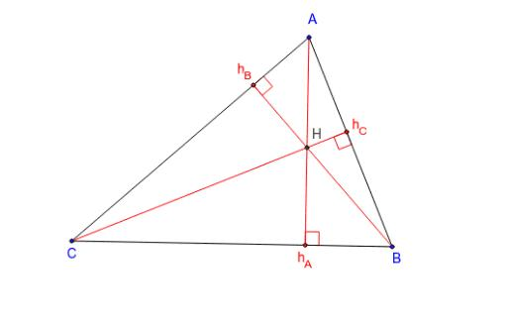
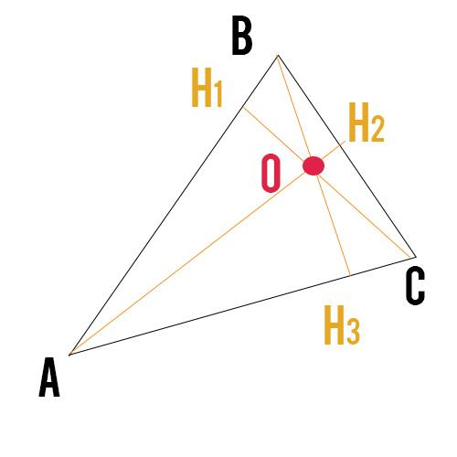
If $H$is the orthocenter:
$$\boxed{H\text{ lies inside }△ABC}$$
The altitudes satisfy:
$$\boxed{AH⊥BC} \\ \boxed{BH⊥AC} \\ \boxed{CH⊥AB}$$

Circumcenter
# Source: AI Source: Provided by: [Data Path: Persons Table -> ID Column: 1, Name_En Column: Motasem Essam] -> From: [ChatGPT] on [7/25/2026]
The circumcenter $O$of an acute triangle is located inside the triangle.
$$\boxed{OA=OB=OC=R}$$
where $R$is the circumradius.
This differs from an obtuse triangle, where the circumcenter lies outside.

Triangle Centers
# Source: AI Source: Provided by: [Data Path: Persons Table -> ID Column: 1, Name_En Column: Motasem Essam] -> From: [ChatGPT] on [7/25/2026]
For a general acute triangle:
- Centroid $G$— inside
- Incenter $I$— inside
- Circumcenter $O$— inside
- Orthocenter $H$— inside
The centroid, circumcenter, and orthocenter lie on the Euler line:
$$\boxed{O, G, H\text{ are collinear}}$$
The incenter generally does not lie on this line.

Relationship Between Sides and Angles
# Source: AI Source: Provided by: [Data Path: Persons Table -> ID Column: 1, Name_En Column: Motasem Essam] -> From: [ChatGPT] on [7/25/2026]
The larger the angle, the longer its opposite side.
For example, if:
$$∠A<∠B<∠C$$
then the opposite sides satisfy:
$$\boxed{BC<CA<AB}$$
Thus, even though all angles are acute, their sizes determine the relative lengths of the sides.

Area
# Source: AI Source: Provided by: [Data Path: Persons Table -> ID Column: 1, Name_En Column: Motasem Essam] -> From: [ChatGPT] on [7/25/2026]
The area can be calculated using the base and corresponding height:
$$\boxed{A=\frac{1}{2}bh}$$
It can also be calculated using two sides and their included angle:
$$\boxed{A=\frac{1}{2}ab\sin{C}}$$
or using Heron's Formula:
$$\boxed{A=\sqrt{s\left(s-a\right)\left(s-b\right)\left(s-c\right)}}$$
where:
$$\boxed{s=\frac{a+b+c}{2}}$$

Real-World Applications
# Source: AI Source: Provided by: [Data Path: Persons Table -> ID Column: 1, Name_En Column: Motasem Essam] -> From: [ChatGPT] on [7/25/2026]
Acute triangles occur in:
- Roof and structural designs
- Bridges and trusses
- Architectural frameworks
- Surveying and land measurement
- Engineering structures
- Computer graphics
- Triangulation systems
- Geometric modeling

Comparison with Other Triangle Types by Angles
# Source: AI Source: Provided by: [Data Path: Persons Table -> ID Column: 1, Name_En Column: Motasem Essam] -> From: [ChatGPT] on [7/25/2026]
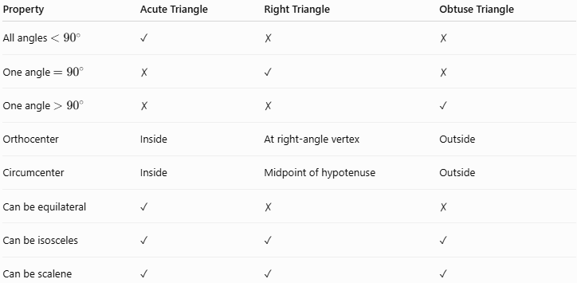
Property | Acute Triangle | Right Triangle | Obtuse Triangle
All angles $<{90}^{∘}$ | ✓ | ✗ | ✗
One angle $={90}^{∘}$ | ✗ | ✓ | ✗
One angle $>{90}^{∘}$ | ✗ | ✗ | ✓
Orthocenter | Inside | At right-angle vertex | Outside
Circumcenter | Inside | Midpoint of hypotenuse | Outside
Can be equilateral | ✓ | ✗ | ✗
Can be isosceles | ✓ | ✓ | ✓
Can be scalene | ✓ | ✓ | ✓

Key Points
# Source: AI Source: Provided by: [Data Path: Persons Table -> ID Column: 1, Name_En Column: Motasem Essam] -> From: [ChatGPT] on [7/25/2026]
- An acute triangle has three angles less than ${90}^{∘}$.
- Its three interior angles always sum to ${180}^{∘}$.
- It has no right or obtuse angle.
- Its longest side satisfies:
$$\boxed{c^{2}<a^{2}+b^{2}}$$
- Its orthocenter lies inside the triangle.
- Its circumcenter lies inside the triangle.
- It can be equilateral, isosceles, or scalene.
- An equilateral triangle is always an acute triangle.
- The centroid, incenter, circumcenter, and orthocenter are all inside an acute triangle.

Conclusion
# Source: AI Source: Provided by: [Data Path: Persons Table -> ID Column: 1, Name_En Column: Motasem Essam] -> From: [ChatGPT] on [7/25/2026]
An Acute Triangle is a triangle whose three interior angles are all less than ${90}^{∘}$. It is one of the three fundamental triangle classifications by angles, alongside the Right Triangle and Obtuse Triangle. Its characteristic geometric feature is that both its orthocenter and circumcenter lie inside the triangle, and its side lengths satisfy the acute-triangle form of the Pythagorean inequality.

